LED Display

Path: Operation >> LED Display.
Steps to reach LED Display:
Step 1 : Operation in Steps to reach LED Display : Go to the Operation module from the main menu.
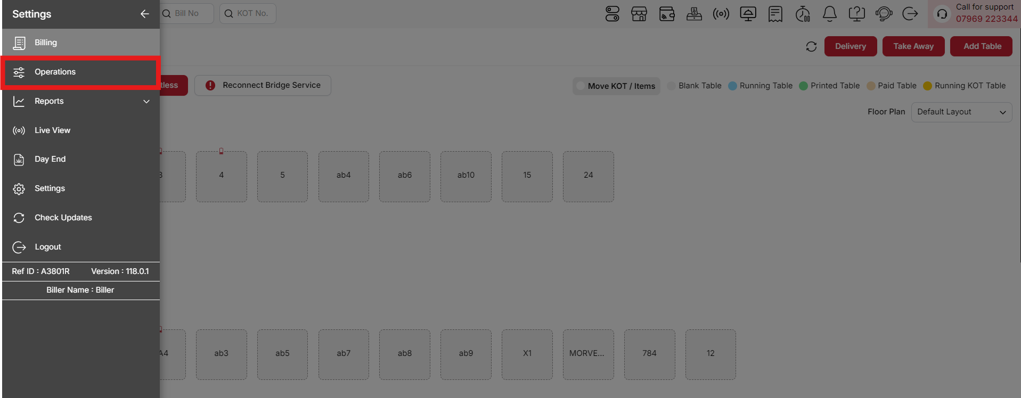
{Image Name: Operations,
Description: The red box highlights the Operations menu in the sidebar, offering tools like Reconnect Bridge Service and order management options. Users can handle tasks such as fixing connectivity and managing tables like Blank Table and Running Table. Here is an image of Step 1 Operations in Steps to Reach LED Display.}
Step 2 : LED Display in Steps to reach LED Display : Select LED Display to configure and manage the customer-facing LED screens for order status, promotions, and announcements.
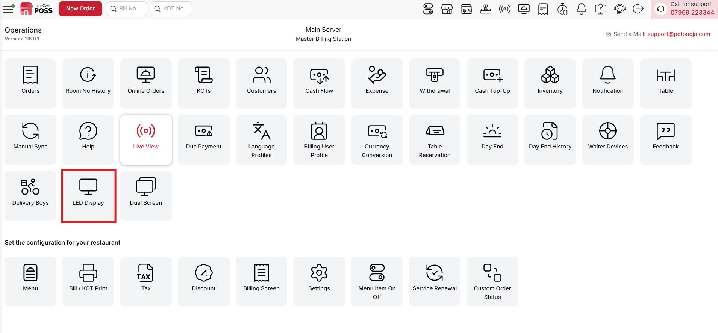
{Image Name: LED Display,
Description: The red box highlights the LED Display option. This feature allows the restaurant to project order details on an external screen, helping staff and customers track the status of ongoing orders easily. Here is an image of Step 2 LED Display in Steps to Reach LED Display.}

Key features Of LED Display :
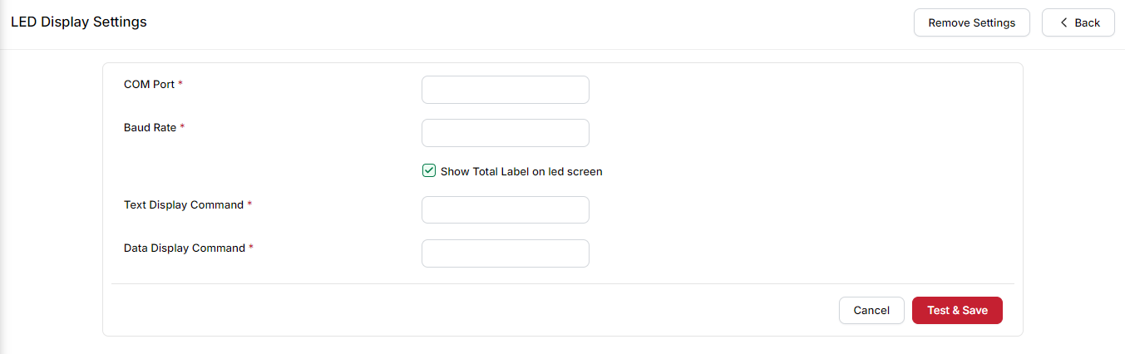
{Image Name: LED Display Settings,
Description: This screen allows users to configure LED display settings by entering COM Port, Baud Rate, and display commands. It helps in showing billing details on the LED screen, with an option to test and save the configuration.}
- (LED Display) COM Port → The communication port used to connect the LED display to the system.
Example: COM3 or COM4 (depending on which port the device is connected to).
- (LED Display) Baud Rate → The speed of data transfer between the system and the LED display. Must match the LED display settings.
Example: 9600, 19200, or 115200 (commonly used baud rates).
- (LED Display) Show Total Label on LED screen → When checked, the total bill amount will also be shown on the LED display.
Example: If the bill is ₹250, the LED will show “Total: 250”.
- (LED Display) Text Display Command → The command format used to send text instructions to the LED display (controls how text appears).
Example: 27,115,50 (this command might control text formatting like position or alignment).
- (LED Display) Data Display Command → The command format used to send billing or order data to the LED display (controls how numbers/amounts are displayed).
Example: 27,81,65,#petpooja_data,13 (this might print the actual order total on the screen).

- (LED Display) Remove Settings → Deletes the current LED display configuration.
  - When clicked, a confirmation popup appears: “Are you sure you want to remove these settings?”
  - You must click Remove in the popup to confirm.
  - Once confirmed, all LED display settings will be cleared.
- (LED Display) Cancel → Discards any changes and keeps the previous settings.
- (LED Display) Test & Save → Tests the entered settings with the LED display and saves them if they are correct.
- (LED Display) Back → Returns to the previous page without making changes.

